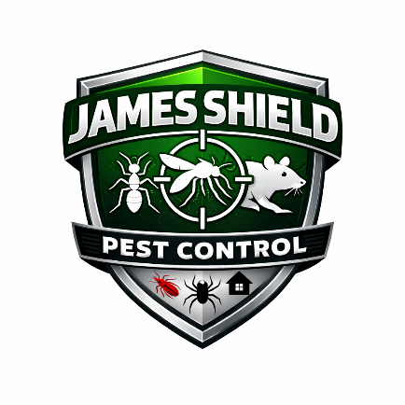
James Shield Pest Control
New Hire Onboarding Guide

1. Purpose
The purpose of this onboarding guide is to ensure a consistent, professional, and welcoming experience for all new employees. A structured onboarding process improves productivity, safety compliance, and employee retention.
This guide outlines the responsibilities of management, Human Resources, and the new employee from offer acceptance through the first 90 days of employment.

2. Pre-Employment Process
2.1 Offer Letter & Acceptance
- Formal written offer issued.
- Compensation, schedule, and start date confirmed.
- Position classification (exempt/non-exempt) determined.
2.2 Pre-Employment Requirements
- Background check (if applicable)
- Drug screening (if required)
- Motor vehicle record check (for driving roles)
- License verification (for technicians)
2.3 Pre-Day-One Preparation (Management Responsibilities)
- Prepare workstation or vehicle assignment.
- Set up email, phone, and system access.
- Prepare PPE and uniforms (if applicable).
- Assign onboarding mentor or supervisor.
- Schedule first-week training sessions.

3. Day One Orientation
3.1 Welcome & Introduction
- Welcome meeting with supervisor.
- Overview of Company history and mission.
- Introduction to team members.
3.2 Completion of Required Paperwork
- I-9 Employment Eligibility Verification
- W-4 Tax Withholding Form
- Direct Deposit Authorization
- Employee Handbook Acknowledgment
- Policy acknowledgments (Safety, FMLA, etc.)
- Benefits enrollment (if applicable)

4. Company Overview
New employees will receive an overview of:
- Company history and leadership
- Organizational structure
- Core values and workplace expectations
- Workplace Conduct & Ethics standards
- Safety culture and compliance

5. Safety & Compliance Training
All employees must complete mandatory training, including:
- Workplace Safety & PPE requirements
- Label Is the Law (pesticide compliance)
- Hazard Communication (SDS)
- Chemical Spill Response
- Timekeeping procedures
- Attendance expectations
Field employees will receive additional:
- Equipment handling training
- Vehicle safety orientation
- Customer service standards training

6. Technology & Tools Setup
Employees will receive training on:
- Company-issued laptop and phone
- Outlook email and calendar
- Timekeeping system
- CRM or scheduling software
- Expense reporting process
Employees must review:
- Electronic Communication Systems policy
- Data security and confidentiality requirements

7. Role-Specific Training
Each employee will receive:
- Job description review
- Performance expectations
- Key performance metrics (KPIs)
- Initial task assignments
Field technicians will complete:
- Ride-alongs
- Field shadowing
- Product handling demonstrations
- Licensing exam preparation (if applicable)

8. First 30 Days
Objectives:
- Understand job responsibilities
- Learn internal systems
- Demonstrate reliability and punctuality
- Complete required certifications
Manager Responsibilities:
- Weekly check-ins
- Provide feedback and coaching
- Monitor performance metrics

9. 60-Day Review
- Informal performance discussion
- Address training gaps
- Evaluate cultural fit
- Reinforce safety and compliance standards

10. 90-Day Evaluation
At the completion of the introductory period:
- Formal performance review
- Confirm continued employment status
- Discuss career development goals
- Review benefits eligibility (if applicable)

11. Remote Employees (If Applicable)
Remote employees must:
- Demonstrate proper home workspace setup
- Maintain availability during scheduled hours
- Complete remote communication expectations
- Participate in virtual onboarding sessions

12. Ongoing Development
James Shield Pest Control encourages continued growth through:
- Continuing education
- Licensing advancement
- Leadership development opportunities
- Annual performance reviews

13. Responsibilities Summary
New Employee Responsibilities
- Complete required paperwork promptly
- Participate actively in training
- Follow safety and conduct policies
- Ask questions and communicate proactively
Supervisor Responsibilities
- Provide structured training
- Offer consistent feedback
- Ensure compliance training completion
- Support employee integration

14. Onboarding Checklist (Summary)
✔ Offer letter signed
✔ Pre-employment checks completed
✔ I-9 and tax forms completed
✔ Handbook acknowledgment signed
✔ Safety training completed
✔ Technology setup completed
✔ 30/60/90-day check-ins scheduled

15. Policy Integration
All employees must comply with:
- Timekeeping Policy
- Attendance Policy
- Safety & PPE Policy
- Workplace Conduct & Ethics Policy
- Benefits Policies

